GSK OTC Dashbord

User Documentation
Version 1.0


Contents
1 Document control 4
1.1 About this document 4
1.2 Changes made to this document 4
1.3 Purpose of this document 4
1.4 Audience for this document 4
2 Assumptions and constraints 5
3 Process 6
4 QC 10
5 Process 18
6 Appendix 19
6.1 Appendix A1: Download FTP Information 19
6.2 Appendix A2: Download Server Information 19
6.3 Appendix A3:Processing Server Information 19
6.4 Appendix A4:File Express Information 19

Document control

About this document
Author | Anika Nower
Published
File location
Status
Confidentiality | This document is confidential and must not be distributed outside of IMS Health.
Copyright | © 2026 IMS Health Incorporated or its affiliates. All rights reserved.

Changes made to this document

Version | Sections changed or created | Date of change | Author or contributor name | Role | Change summary

Purpose of this document
The purpose of this document is to describe GSK OTC Dashboard.

Audience for this document
This document has been written for:
- Production team members

Assumptions and constraints

ID | Assumptions

ID | Constraints

Process
Step# | Step Description
Sample mail
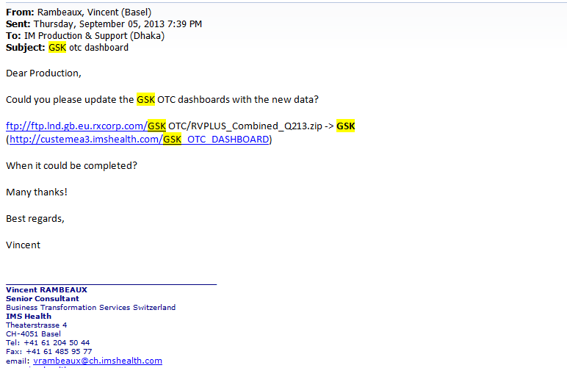
 | Log on to the server using Appendix A2 183.174 diye namate hobe
Go to D:\CustomData\GSK OTC Cube\Input
Download the file using Appendix A1
Unzip the file using Extract to folder.

Go to location
D:\CustomData\GSK OTC Cube\Tools\PADDS Convert Tool\Convert50 Open convert.exe
1.Click analyze from menu bar.
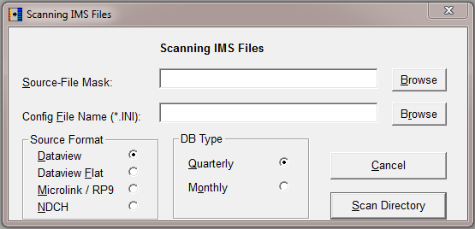
2.Browse source file mask: D:\CustomData\GSK OTC Cube\Input\RVPLUS_COMBINED_QmYY
3.Select .PRM file and open (DBrvplus.PRM)
4.Select Quarterly
5.Click Scan Directory
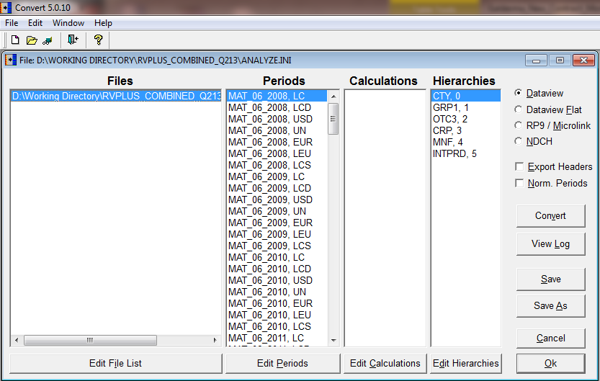
- Check Export headers, Norm. Periods
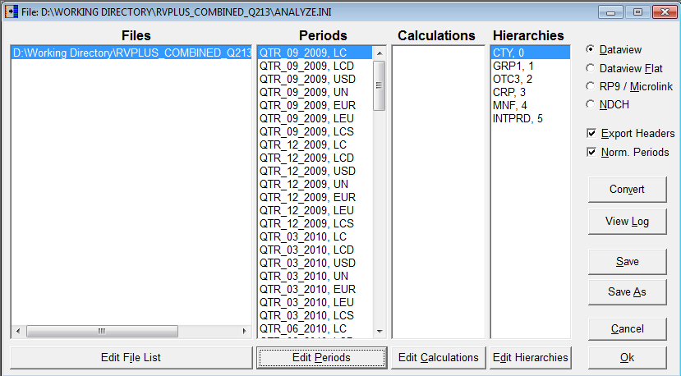
7.Click Edit Periods
Select all MAT and delete
Click OK.
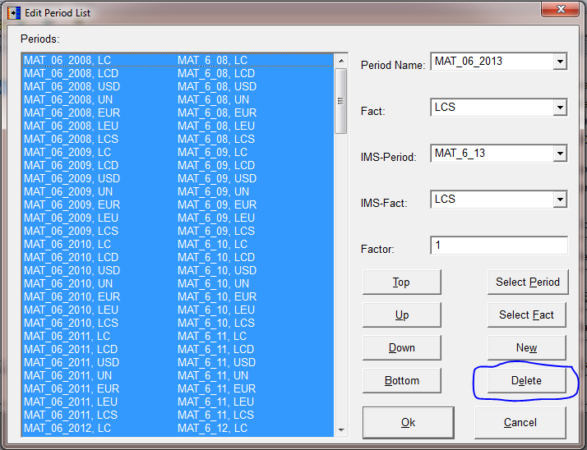7. Click edit Hierarchies
Delete .dll file
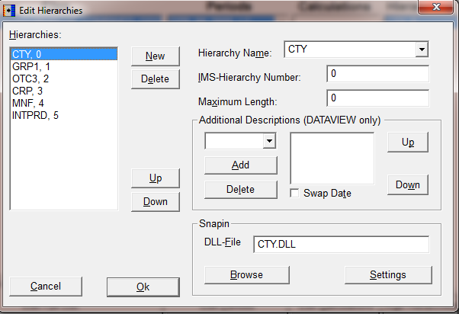

 | Click ok
 | Click convert→ yes
- on | One massage will show with the last line ready.
Close window.
‘DBrvplus.OUT’ file will generate in location D:\CustomData\GSK OTC Cube\Input\RVPLUS_COMBINED_QmYY
Login to database using Appendix A3
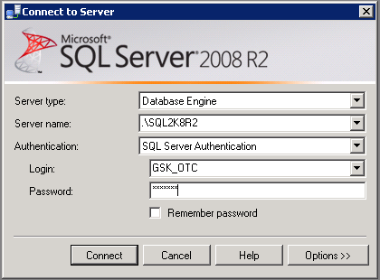
Run below query
TRUNCATE table dbo.UNPIVOTED_IMS_RAW_CTY_ALL_COUNTRY_DATA_BK

INSERT INTO UNPIVOTED_IMS_RAW_CTY_ALL_COUNTRY_DATA_BK
SELECT * from UNPIVOTED_IMS_RAW_CTY_ALL_COUNTRY_DATA

TRUNCATE table dbo.UNPIVOTED_IMS_RAW_CTY_ALL_COUNTRY_DATA

Then import ‘DBrvplus.OUT’ to table name UNPIVOTED_IMS_RAW_CTY_ALL_COUNTRY_DATA
Steps:
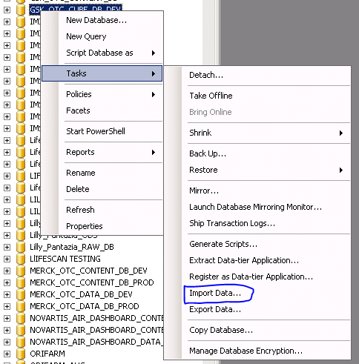

Select Data source as Flat file source.
Browse the file from the respective location
Check the Column name in the 1st data raw
Text qualifier :”
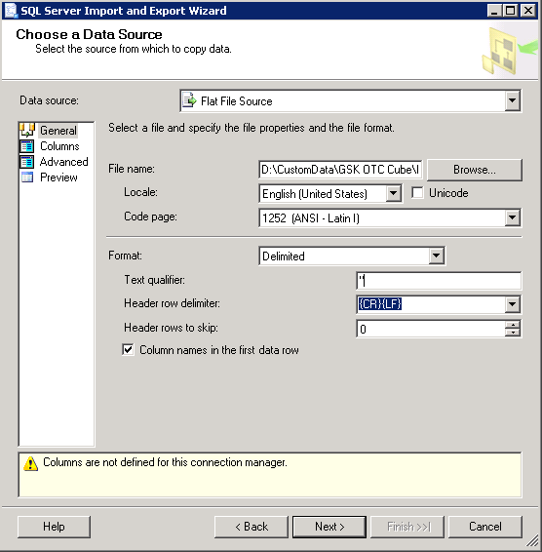

Go to Advanced tab
CTY - > PERIOD : Unicode string [DT_WSTR] (50)
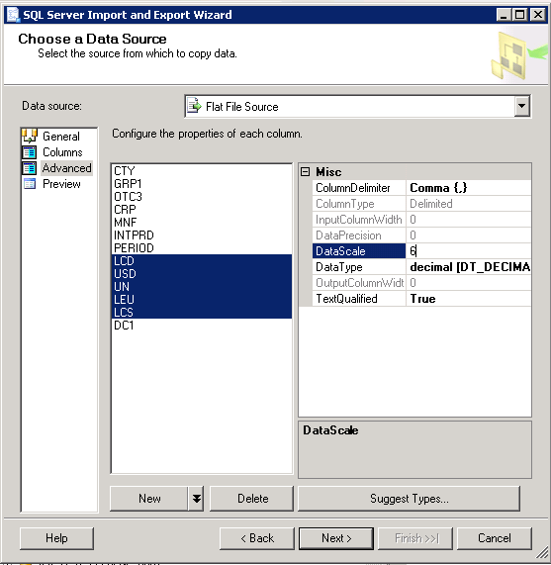

MEASURES : decimal > 18,6

Click Next
Ckeck Database information.
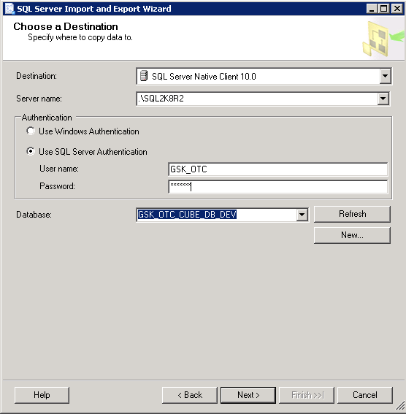
Click next
Select destination table.
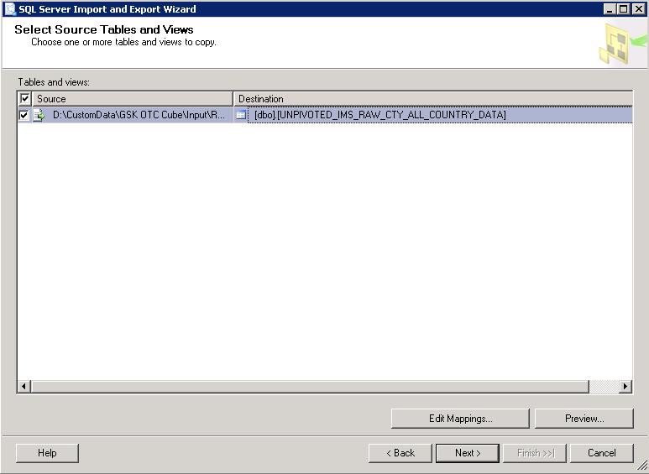

Go to edit mapping
Set OTC3→ CATS
LEU → EUR
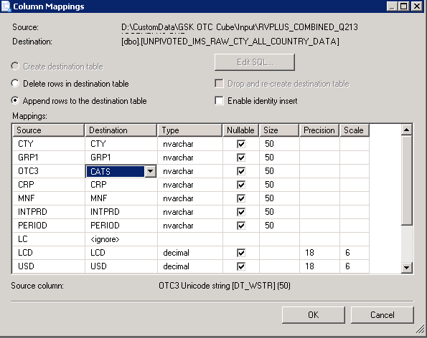

Click ok, next next finish

Import done..
Run below query
SELECT distinct [CTY]

FROM [GSK_OTC_CUBE_DB_DEV].[dbo].[UNPIVOTED_IMS_RAW_CTY_ALL_COUNTRY_DATA]

We will find three country which has two entry. Such as
BRAZIL, BRAZIL NEW
CHINA, CHINA NEW
MEXICO, MEXICO NEW

We have to delete BRAZIL, CHINA, MEXICO from table.
delete FROM [GSK_OTC_CUBE_DB_DEV].[dbo].[UNPIVOTED_IMS_RAW_CTY_ALL_COUNTRY_DATA]
where CTY='MEXICO'

then update table with BRAZIL NEW with BRAZIL and with two others.

update [GSK_OTC_CUBE_DB_DEV].[dbo].[UNPIVOTED_IMS_RAW_CTY_ALL_COUNTRY_DATA]
set CTY='BRAZIL' where CTY='BRAZIL NEW'

run below Query
exec LOAD_CUBE_DATA_WRAPPER

Login to Server 10.223.200.39

Open SQL Server Management Studio - Select Analysis Service (10.223.200.39\SQL2K8R2)

Select Database GSK_OTC_CUBE_2 - Right Click - Process – OK

Successfully done.
DEV site : http://10.223.200.22/GSK_OTC/Login/Login.aspx
After confirmation >
Take backup of 'GSK_OTC_CUBE_2'
Uncheck the checked option.
transfer this to GDC.
Location : 162.44.25.28
take backup 'GSK_OTC_CUBE_2' to 'D:\GSK_OTC\GSK_OTC'
restore cube to 'GSK_OTC_CUBE_2' from your transferred zip file
check Allow database overwrite
http://custemea3.imshealth.com/GSK_OTC_DASHBOARD

Username : Ims
Password: Ims

Process

The table below lists other materials that are relevant to this document.
Title | Author | Version | Date | Location

Appendix

Appendix A1: Download FTP Information
Key | Value
FTP Server: | ftp://ftp-emea.rxcorp.com/
Username: | D08044
Password: | CHProd
Location: | Level3_Global_Analysis/Internal/

Appendix A2:Processing Server Information
Key | Value
Server Address: | 10.223.200.39
Username: | DACASVC-RDPAdmin
Password: | Wh2t3v3r

6.3 Appendix A3: Database server
Key | Value
DB location: | 10.223.200.39\SQL2K8R2
Username: | GSK_OTC
Password: | GSK_OTC
Database name: | GSK_OTC_CUBE_DB_DEV

